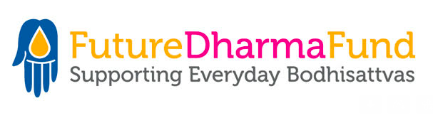

Vacancy at FutureDharma Fund
Supporter Care Officer
Full-Time / Remote Working

Real Living Wage plus pension contributions and generous retreat allowance

Are you a Mitra or Order Member wanting to work in a forward-looking Right Livelihood Team?

FutureDharma has grown over the last 5 years and now supports 45 International Triratna projects including those of India Dhamma Trust. We’re seeking a committed and enthusiastic individual to join us. Could it be you?

As Supporter Care Officer you’ll play a vital role right at the heart of our team.

You’ll take care of our supporters, thanking them for their gifts, answering their enquiries, and ensuring that their gifts are securely processed and recorded. You’ll also work closely with our fundraisers, supporting their work by supplying them with accurate data and information.

Could you be the person we’re looking for? If you’d enjoy working in a Triratna team Based Right Livelihood please read our Job Description and complete our application form.

Please send your application to: danayutta@futuredharma.org
Closing date for applications: 18th March 2022
Interviews (via Zoom): week beginning 28th March 2022

