Through this meditation, we express our wish for world peace and the well-being and happiness of all living beings. Our meditation practice helps us to be the best we can be, and do the best we can do for our own well-being as well as that of others.

When faced with suffering, inequality, conflict and war, we want to respond with kindness and compassion. We want to do what is within our power to alleviate this suffering through skilful peaceful action. As Buddhists, we believe that the transformation of oneself and of the world cannot be separated.

Our heartfelt wish is that our governments and others in power have the courage to choose peaceful means to overcome conflict, and thereby break the cycle of fear and violence affecting our 21st century world. This is why we also wish to express our solidarity with those peacefully resisting government plans to spend £100 billion on renewing the UK’s nuclear weapons’ system, Trident.

If you would like to explore Buddhist meditation – and there is no need to become a Buddhist to do this – we would like to warmly invite you to our drop-in meditation classes on

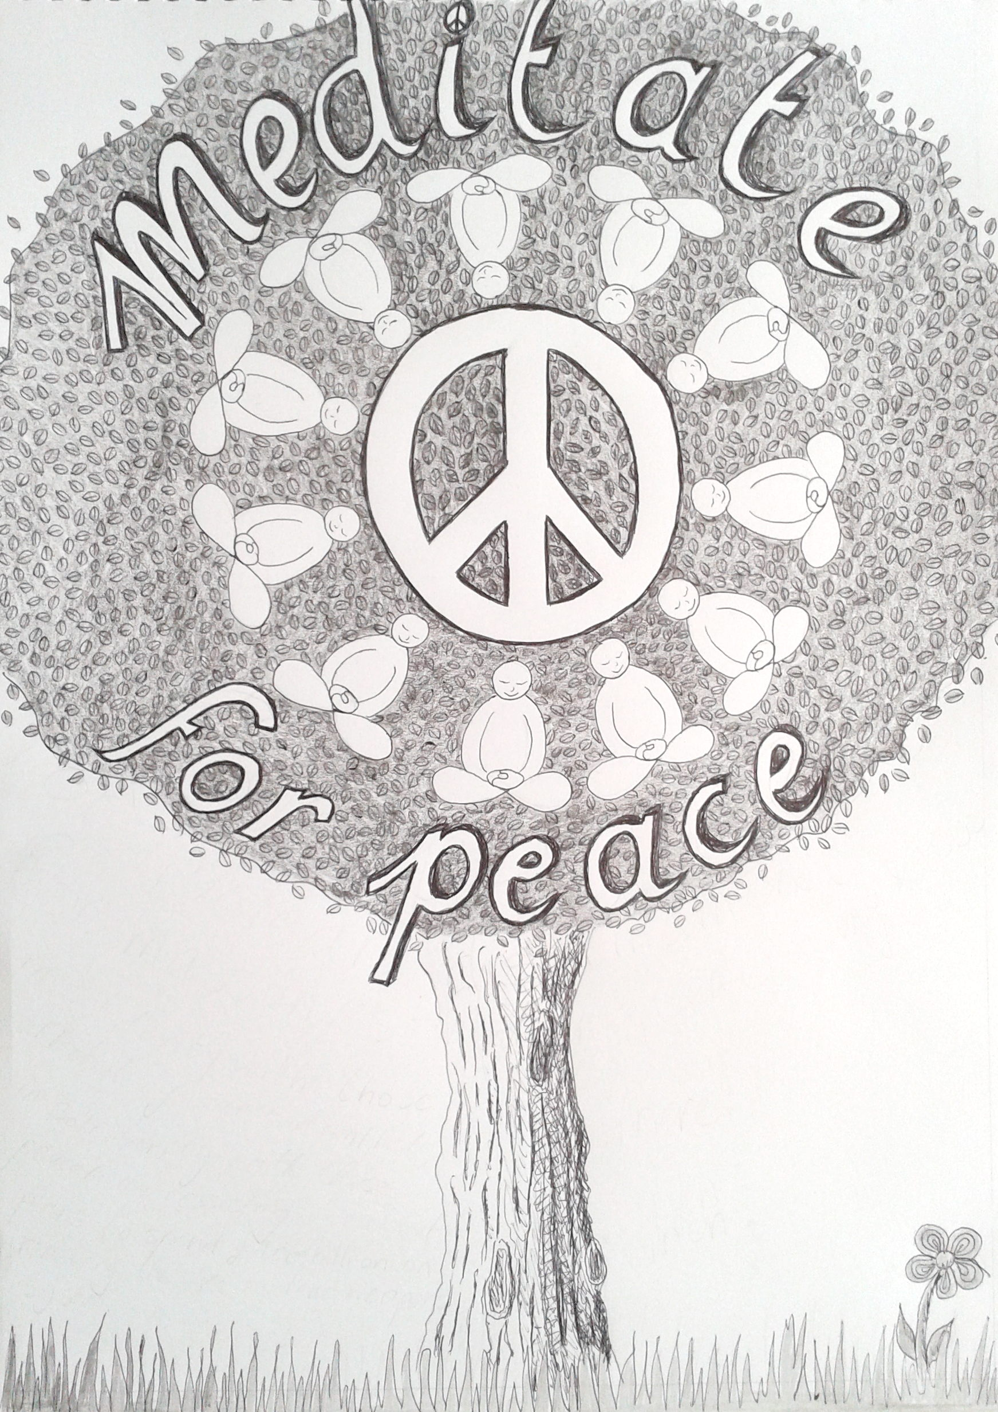
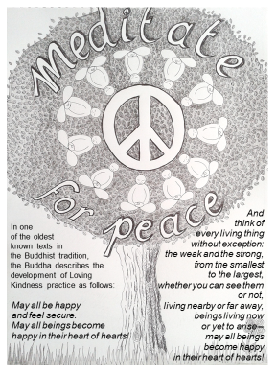
May all be happy
and feel secure.
May all beings become
happy in their heart of hearts!
And
think of
every living thing
without exception:
the weak and the strong,
from the smallest
to the largest,
whether you can see them
or not,
living nearby or far away,
beings living now
or yet to arise –
may all beings
become happy
in their heart of hearts!
In one
of the oldest
known texts in
the Buddhist tradition,
the Buddha describes the
development of Loving
Kindness practice as follows:

