meditation

There are many things in life that are beyond our control. However, it is possible to take responsibility for our own states of mind – and to change them for the better. According to Buddhism this is the most important thing we can do. It is the only real antidote to our personal sorrows, as well as the anxiety, fear, hatred and confusion that beset the human condition. Transformation of our mind and personal actions leads to transformation of our world.

Meditation is a means of transforming the mind. Buddhist meditation practices encourage and develop clarity, emotional positivity, and a calm seeing of the true nature of things. By engaging with a particular meditation practice you learn the patterns and habits of your mind, and the practice offers a means to cultivate new, more positive ways of being. Regular work and patience can deepen into profoundly peaceful and energised states of mind. Such experiences have a transformative effect and lead to a new understanding of life. Through practice we aim to bring benefit to ourselves and our world.

**************************
We are really delighted to be able to pass on what we have learned through our spiritual practice. The centre is run on a completely voluntary basis. To help us in this we ask for suggested donations for our courses and events. Our centre runs on the monies received from activities so your donation keeps the centre running and available for others. However, if money is tight please just come.

ipswich buddhist centre
4 friars bridge road
IP1 1RR

(Downhill from the AXA building off the Civic Drive roundabout.)

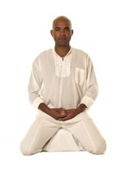

For starting dates for courses/activities, please either phone or check our website.

phone: 01473 211516

www.ipswichbuddhistcentre.org.uk

Ipswich Buddhist Centre is run by FWBO (Ipswich)
Registered Charity (no. 1023335).

ipswich buddhist centre

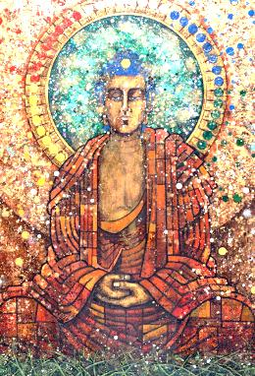

introductory events

introductory events

newcomers’

every wednesday evening

7.30pm – 10.00pm (open from 7.00pm)

Suggested donation £6

A chance to find out about the Centre, and the Buddhist way of life. Each night there is an introduction to meditation followed by
discussion on the Buddhist way of life.
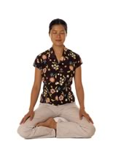

lunchtime meditation

every tuesday

1pm — 2pm.

Suggested donation £3

Drop in to be introduced to one of two
meditations.

buddhism

Buddhism is a path of practice and spiritual development leading to Insight into the true nature of reality.

Buddhist practices like meditation are means of changing yourself in order to develop the qualities of awareness, kindness, and wisdom. Through practice we aim to bring benefit to ourselves and our world.

The experience developed within the Buddhist tradition over thousands of years has created an incomparable resource. We show how to apply this in the context of the modern world.

Because Buddhism does not include the idea of worshipping a creator god, some people do not see it as a religion in the normal, Western sense.

The basic tenets of Buddhist teaching are straightforward and practical: nothing is fixed or permanent; actions have consequences; change is possible.

So Buddhism addresses itself to all people irrespective of race, nationality, caste, sexuality, or gender. It teaches practical methods which enable people to realise and use its teachings in order to transform their experience, to be fully responsible for their lives.

meditation and buddhism courses

wednesday evenings

7.30pm – 10pm

Cost £65 (£45 low income - £25 no income)

An introduction to two meditation practices and practical ways from the Buddhist tradition to transform our lives. All courses run for 6 weeks. Please book in advance. A deposit of £10 is needed to secure a place.

early morning meditations

wednesday & friday

7.30am – 8.30am

Suggested donation £3

If you know how to meditate – join us for an early morning meditation.

open days

We have ‘open days’ periodically. Please check the website for further details.

