FutureDharma Fundraiser
Want to help Triratna reach more people around the world?

The FutureDharma team is looking for a fundraiser to join Amalavajra at Adhisthana

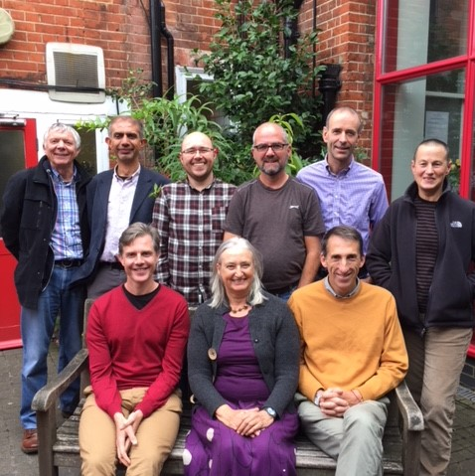
Applications are invited from members of the Triratna Buddhist Order or mitras training for ordination for the post of Fundraiser for this exciting, bold and important new initiative. The next years are a crucial time for Triratna and arguably the world and the Fund aims to resource the unity of Triratna, the depth of practice within our community and our breadth of reach to a suffering world.
You will help raise £250,000 per year for FutureDharma Fund projects around the world and you’ll do this by forming and developing good relationships with people around the Triratna world, and communicating persuasively about projects they care about.
You’ll work most closely with Amalavajra as Fundraising Director, at Adhisthana, as well as with other team members: Liz Bassett as Supporter Care and Communications Manager, Viryanaga as Programme Manager, and Nandavajra as Director. We are also all part of the European Development Team.
Financial Support for the post is on a needs basis and as defined in the present Development Team ethos. The level of support will be determined through discussion with Nandavajra and in consultation with the FutureDharma Fund Trustees.
Applying for the post
For further information, job description and application form please visit TBCO or please contact Nandavajra (nandavajra@triratnadevelopment.org / 07583 107258).
The closing date for applications is 13th November and interviews will take place in the week beginning 4th December. The post will commence end of February/March 2018 and will be subject to a 6 month trial period.

