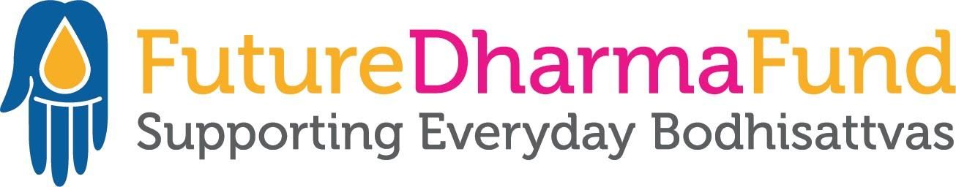

Rare opportunity for a full-time*, remote-working, TBRL role
- Do you want to work for the future of the Dharma and our movement?
- Would you thrive in an environment working with other committed Buddhists?
- Do you have the energy and drive to fundraise for vital projects?
It isn’t often that the opportunity to work in an excellent Team Base Right-Livelihood role comes up, so don’t miss out.
Could you be FutureDharma’s newest Fundraiser?
Since our launch in 2016, FutureDharma Fund has grown to support 45 international Triratna projects, including those of the India Dhamma Trust, and raised over £1,200,000. This year we aim to raise £500,000 for this vital work.
We are now seeking an inspired and engaged Order member, or Mitra training for ordination to join our skilled, dynamic, and harmonious team as a Fundraiser. We hope to make a full-time appointment but *will consider part-time options.
This is a remote working role with a significant online communication component.

You will be entrepreneurial in the sense of being bold and confident in asking people to give, and motivated by success in this. You will approach donors on the telephone, by email, and via Triratna online festivals and events. Whilst we would like to recruit an experienced fundraiser, training would be available to the right candidate who would be willing to make a longer-term commitment to FutureDharma.
You’ll work closely with Karunatara (Head of Major Relationships), and with Alex Lodge (Fundraising and Communications Director) and Sugarbha (Major Donor Fundraiser). You’ll also be part of a wider team including Nandavajra (Director), Danayutta (Finance Director), Alex Beard (Communications Officer), Jnanaruchi (Programmes Manager), Simhasraddha (Supporter Care Manager), Pundarika (Supporter Care Officer), Satyadarshin (Systems Manager) and Visarada (Bookkeeper).

Our trustees represent Triratna’s Three Strands, and we take our strategic lead from the International Council.
Please download the job description to find out more and the application form to apply. Upon application please include a copy of your CV.

All applications should be sent to nandavajra@futuredharma.org . If you would like to have an informal discussion about the role, please email Nandavajra in the first instance.

Closing date for applications: 17th March 2023

Interviews will take place the week commencing: 27th March 2023

