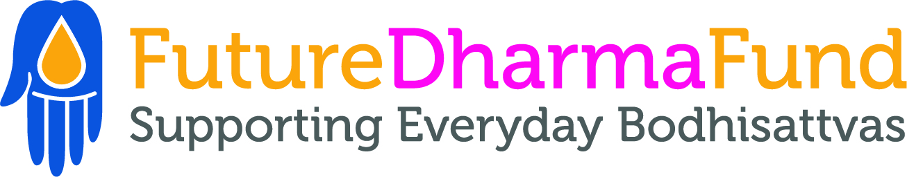

Fundraiser: February 2023

Job Title
Fundraiser

Hours
Full-time, 35hrs per week (part-time will be considered)

Reports to
Head of Major Relationships

Summary of role
Through online, face-to-face, phone, and major donor fundraising you will help us to raise £500k a year for vital Dharma projects all over the world.

Team Context

You’ll work closely with Karunatara (Head of Major Relationships), and with Alex Lodge (Fundraising and Communications Director) and Sugarbha (Major Donor Fundraiser). You’ll also be part of a wider team including Nandavajra (Director), Danayutta (Finance Director), Alex Beard (Communications Officer), Jnanaruchi (Programmes Manager), Simhasraddha (Supporter Care Manager), Pundarika (Supporter Care Officer), Satyadarshin (Systems Manager) and Visarada (Bookkeeper).

Responsibilities

You will be responsible for supporting our online, face-to-face, phone, and major donor fundraising. Your tasks will include:

- Conducting fundraising appeals at Buddhist Centres and on retreats
- The creation of content for digital fundraising
- Manage and develop your own portfolio of major donors in consultation with the Head of Major Relationships
- Support other fundraising activities as required, for example engaging in phone appeals to FutureDharma and IDT supporters and donors, leading fundraising at events, or providing coaching for fundraising at events
- Participate in the Fundraising and Communications team planning and progress meetings
Skills and Characteristics
Essential
- Entrepreneurial in the sense of being bold and confident in asking people to give, and motivated by success in this
- Motivated by fundraising targets and key performance indicators
- Inspired by and committed to Bhante’s vision of Sangha and Dharma practice
- A sensitive and persuasive communicator, especially face to face and on the phone
- Able to make the case for support in writing
- Motivated to engage with digital systems to support and execute your work.
- Conscientious and reliable
- A Mitra training for ordination or an Order Member
- Willing to travel (including overseas) and occasionally work unsocial hours and to attend in-person meetings as required
- Able to work well in a team environment, handle multiple assignments and meet deadlines.
- Creative and strategic thinker with good judgment and the ability to make independent decisions in a changing environment.
- Confident and proficient in using MS Office, and Google equivalents, including online file storage platforms (e.g. Gdrive)
- Creative and reliable, with an eye for detail, especially in relation to written communication with supporters
- Inspired and motivated by being part of a dynamic, forward-looking team
Preferred
- Experience of fundraising with Major Donors and/or individual giving generally
- An Order Member
- An understanding of FutureDharma’s vision, structure, and activities to date

Training

Training will be offered to the right candidate consisting of the Certificate in Fundraising from the Chartered Institute of Fundraising (CIOF). Given this significant investment, training will be offered on the basis of a commitment to remain with FutureDharma for a minimum of 3 years.

Location

This is a remote working role with a significant online communication component. Under normal circumstances your attendance would be expected at in-person meetings held in London every 6 weeks. Twice a year we hold team residential events, for 5 days, at Adhisthana that you would also be expected to attend.

Financial Support

If you live in the UK you will receive the Real Living Wage equivalent to £10.90 per hour (or £11.95 if you live in Greater London). If you have additional financial needs due to dependents or long term health issues, then an additional supplement may be considered. In addition to the base salary, our support package also includes 40 days paid leave per year (including public holidays), a generous retreat allowance, home working expenses and pension contributions.

