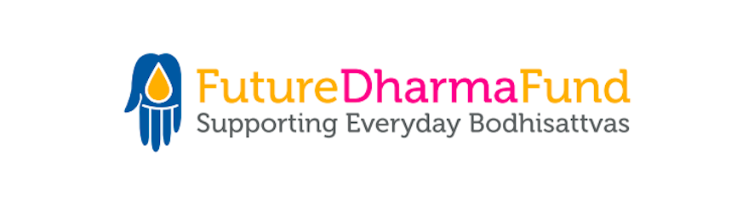

Vacancy at FutureDharma Fund
Communications Manager
Full-Time / Remote Working

Real Living Wage plus pension contributions and generous retreat allowance

Are you a Mitra or Order Member wanting to work in a forward-looking Right Livelihood Team?

FutureDharma has grown over the last 5 years and now supports 45 International Triratna projects including those of India Dhamma Trust. We’re seeking a committed and enthusiastic individual to join us. Could it be you?

As Communications Manager you’ll play a vital role in engaging people in Triratna with the work of our projects.

You’ll help take FutureDharma and our work into its next phase, developing a strategy to further broaden our supporter list using our own and partners’ email and social media channels. You’ll work with other Triratna bodies such as the international Council and The Buddhist Centre Online to create and host online engagement events and festivals. You’ll also work closely with our fundraisers, supporting their work by supplying them with inspiring content and stories of how FutureDharma projects are helping people transform their lives.

Could you be the person we’re looking for? If you’d enjoy working in a Triratna team Based Right Livelihood please read our Job Description and complete our application form.

Please send your application to: danayutta@futuredharma.org
Closing date for applications: 30th March 2022
Interviews (via Zoom): 11th & 12th April 2022
Anticipated start: week beginning 16th May 2022

