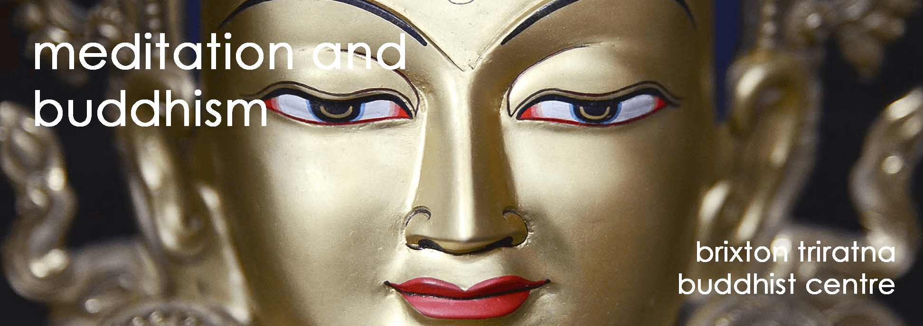
Brixton Buddhist Centre
Part-time Centre Manager - Job Description
Purpose and scope of the job
Activities at the Brixton Buddhist Centre has been developing, and at the same time the close-knit friendly sangha is growing and deepening. Until now we have been run solely on the support of volunteers, but with the number of weekly events also growing, along with the vision of taking the Dharma out more into the communities of Brixton, we are now looking to recruit the first member of what might later become a thriving centre team.
Responsibilities
This is a 2-day per week role (0.4 FTE), handling programming, bookings, advertising, promotion and volunteer coordination, with the aim of growing attendance at our classes and courses. In addition, you would act as a secretary to the Brixton Trustees at their bi-monthly meetings. Although initially this role will be largely administrative, you will be helping move the centre forward significantly, and so there is scope to expand the role over time in line with increased income.

Secretary to the Trustees
- Planning and coordinating trustee’s meetings
- Taking minutes and writing agendas
- Drafting proposals or documents as required

Programme and Bookings Management
- Handling the events programme with Viryanaga
- Coordinating teacher’s days/festivals/special events
- Finding course leaders and teams
- Managing course and retreat bookings and providing ‘customer service’
- Negotiating with venues and making venue bookings

Communications and Promotion
- Handling enquiries about classes, courses or retreats
- Creating a system to coordinate events announcements at classes
- Helping to oversee the work of the Brixton ‘Media Team’, for example: image design, event listings, social media posts, website updates and development.
- Helping with Gift-Aid and/or mailing list admin
- Development of new advertising channels i.e. local community forums, videos and media, recorded talks etc.
If time and interest permits, after the initial phase of the role there is also scope for this person to work on:

Growing our dana economy
- Development of standing order dana
- Crafting of fundraising campaigns
- Seeking grants and financial support from external bodies
Skills and Characteristics

Essential
- Passionate about and committed to Triratna's vision of sangha and Dharma practice, and appreciate Brixton Buddhist Centre’s place in that.
- Be willing to actively participate in the Brixton sangha, be that attending classes, supporting courses or other activities.
- Be organised, self-motivated and conscientious with work activities.
- Be a good communicator, whether face to face, on the telephone or in writing.
- Be comfortable with significant periods working in front of a computer.
- Be a mitra or someone in a study group moving towards becoming a mitra.
- Willing to travel within London as required by the needs of the role.

Ideal
- An Order Member or mitra training for Ordination.
- Professional experience in advertising, promotion, web development, or fundraising.
- Be confident, active and creative with social media or promotional material.
- The ability to work flexibly, and to attend meetings when necessary.
- Well ‘networked’ in Triratna.
Team and Work Context
You will work most closely with, and be managed by Viryanaga. Although your work hours could offer flexibility, you may spend up to one day per week working alongside Viryanaga. Your remaining time will be spent working independently from home, or elsewhere in London as required, with the occasional need to attend evening trustee’s meetings.
The other trustees of Brixton Buddhist Centre are currently Suddhaka, Ratnachuda, Amarapuspa, Maitrinara and Amaladana who will all contribute to the role.
Brixton Buddhist Centre does not yet have a building of its own, but instead we currently rent space in two nearby venues, a room in a yoga studio and a basement in a vegetarian/vegan cafe. These host Brixton’s two weekly classes for newcomers and regulars, a weekly course evening, and occasional weekend events. In addition, we hold at least two weekend retreats a year at various Triratna retreat centres in the UK.
Timing
- Closing date for applications 3rd Sept 2018
- Shortlist candidates will be asked to meet some of the Brixton trustees after the closing date
- Start date negotiable, but ideally from October 2018
- There will be a trial period of six months, continued employment will dependent on the outcome a review towards the end of this trial period.
Support
Financial support for the post is provided on a needs basis, as defined by the common ethos for supported posts within the Triratna Buddhist Community. Beyond provision for reasonable needs, this support will include a retreat allowance and pension contributions. The level of support will be agreed in discussion with the Brixton Buddhist Centre trustees.
For further information or to express an interest in this role contact viryanaga@brixtonbuddhistmeditation.org

