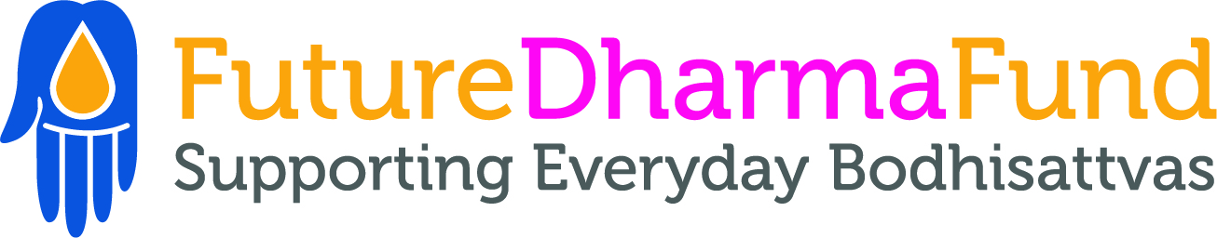

FutureDharma Team application form

Please write about 1000 words, and no more than 1500, covering the following areas:

Your name and contact details.

- Legal name:
- Order name if applicable:
- Age:
- Address:
- Email:
- Phone:

Please give the names (and contact details) of 2 people that know you well enough in a Triratna context for us to talk to about your suitability for this job.

Why would you like to work for FutureDharma?

Referencing the job description, please tell us which responsibilities and activities which you are most inspired by?

What skills and experience would you bring to this role? It is best to give examples from projects you’ve been involved with in the past, in relation to the skills and qualities listed in the job description.

What do you think the challenges of this work might be, and how would you approach them?

Are there any areas either personal, spiritual or occupational that you feel you might need extra support around in this role?

How long might you see yourself wanting to work for FutureDharma, what are your current longer-term aspirations?

Please tell us about any practical needs you have in terms of working hours, ability to travel and attend FutureDharma Fund meetings, place of work, and financial support (beyond what is advertised)

Please return your completed application to Amalavajra at amalavajra@futuredharma.org.

