Buddhist Action Month

BAM Handbook:
Ideas, Tips, Inspiration

Prepared by Christine Thuring, BAM Coordinator
for the Network of Buddhist Organisations (2018)

Buddhist Action Month: what is it? 3
Who’s involved: cross-traditional and inclusive 4
Network of Buddhist Organisations UK (NBO) 4
Dharma Action Network for Climate Engagement (DANCE) 4
Annual theme 5
Buddhist Action Month 2018: Transforming Self, Transforming World 5
7
Get involved: BAM actions and precepts 8
Individual BAM activities 8
Adjust your lifestyle 8
Become an Ethical Consumer 10
Divest your money 10
Group BAM activities: organising for your spiritual community 12
Organising for your sangha 12
Timing and logistics 12
Promoting your BAM action or event 13
UN Sustainable Development Goals 14
Resources for our times 15
Good reads 15
Fims and documentaries 16
Talks 17
Suggestions for BAM Activities 18
Verses for inspiration 22
The Karaniya Mettā sutta 22
“Active Hope”, by Joanna Macy 23
“This is Your Age”, a Poem for Generation Hope 24
Letter of encouragement from Nichiren 24
“Service to humanity is another name for Zen training” 25
A Verse from the Buddha’s Udana (not decided yet) 25
Description of the Bodhisattva Ideal (e.g., Mahagovinda sutta; Buddhavamsa of the Khuddaka-Nikaya) (not decided yet/ found yet) 25
Verse from Dhammapada in Joy chapter (not found yet) 25
Visuddhimagga sutta: Path of Purity (not found yet) 25
Recycling sutta 25

Buddhist Action Month: what is it?

June is Buddhist Action Month: BAM!

BAM is a contemporary Buddhist festival initiated by the Network of Buddhist Organisations (NBO) in 2012 to inspire and support social change and care for the environment. BAM encourages Buddhists of all traditions to take their practice more explicitly into the world as a united force for good, exemplifying compassion, ethics, emotional positivity, creativity and wisdom, for the benefit of all beings. Being limited to June, BAM is an opportunity to adjust a habit or to initiate an ethical ideal that remains an idea. It’s also the season to be out in the world, connecting with the natural environment and with other beings.

As a grassroots project that explores the challenges of ethical living in the 21st century, BAM encourages small changes and celebrates our aspirations. With faith in impermanence and process, even the smallest lifestyle adjustments are a great way to test out karma, and to generate awareness, energy and purpose.

First initiated in the UK by the NBO, after five years Buddhist Action Month was being celebrated beyond Britain, with actions and activities happening across Europe and in some places in Australia and North America. Not surprisingly, social media has been a useful tool facilitating this increased participation. While face-to-face contact is optimal for this project, and promotion through physical posters and word-of-mouth, social media extends our reach and help us make connections in the wider world. Some of us might choose to sign off from social media for the month of June, to simplify our lives and reduce the input we take in. On the other hand, some of us might choose to use social media for the month of June as an exercise in mind training, and with an emphasis on establishing mastery and awareness.

Whatever joy there is in the world,
All comes from desiring others to be happy
And whatever suffering there is in the world,
All comes from desiring myself alone to be happy.

But what need is there to say much more?

The childish work for their own benefit,
The Buddhas work for the benefit of others.
Just look at the difference between them!

Santideva, Bodhicharyavatara, ch 8, 129-130

Who’s involved: cross-traditional and inclusive

Buddhist Action Month is inclusive, and invites practicing Buddhists to get involved, as well as those do not consider themselves Buddhist but who are receptive and sympathetic to the Dharma, the teachings of the Buddha. BAM therefore encourages anyone to get involved who is interested in Buddhism, in ecological or social justice, or in the possibility that meaningful change will be through spiritual means.

Network of Buddhist Organisations UK (NBO)
The Network of Buddhist Organisations UK (NBO) was founded in 1993 to:
a) promote fellowship and dialogue between Buddhist organisations.
b) facilitate co-operation in matters of common interest.
c) work in harmony with other Buddhist and like-minded organisations (such as the European Buddhist Union and Inter Faith Network for the UK.)
The NBO is a registered charity, entirely dependent on the generosity and activities of its volunteers. Our members are volunteers inspired by their own traditions and forms of practice. As such, the NBO does not promote, validate or endorse any Buddhist tradition, but aims to work for the good of Buddhism in Britain, for the good of society. As the founder of Buddhist Action Month, the NBO invites all its members to get involved, including Buddhists with no affiliations and individuals belonging to its member organisations, which include:
London Shambhala Centre | Zenways
Sangha House | FPMT UK
La Verita Studios Ltd | SGI UK
Buddhist Group of Kendal | Triratna Buddhist Order & Community
New Buddha Way | Order of Buddhist Contemplatives
Wild Goose Zen Sangha | Western Chan Fellowship
IPBS UK (Fo Guan Shan) | Amida Trust
Stonewater Zen Sangha | Jamyang Buddhist Centre Leeds
The Shrimila Trust (Awakened Heart) | Buddhist Healthcare Chaplaincy Group

It is worth noting that the BAM committee is comprised of individuals from a number of different traditions, including Triratna, SGI-UK and Western Chan Fellowship. Working on such a project with such a diversity of traditions is an enriching experience. If you are interested in maintaining Buddhist Action Month as an annual tradition, then please get in touch and consider getting involved with the BAM committee. Just email chair@nbo.org.uk with Buddhist Action Month as the Subject.

Dharma Action Network for Climate Engagement (DANCE)
DANCE is an informal partner of Buddhist Action Month, as both share the same interests and there has been friendly cross-pollination in the form of collaborations (e.g., Green Earth Awakening) and friendship. DANCE was established at Gaia House as a self-organising network for individuals interested in engaging with issues around climate change. Connections between BAM and DANCE could be advanced, at little expense, which would be beneficial to both. Check the DANCE website to find out about more about DANCE, or to find groups or actions near you. http://www.thedancewebsite.org

Annual theme

Each year, Buddhist Action Month is given a particular theme that is inspired by contemporary matters. For example, the theme of BAM 2017 was Connecting for Change, as mainstream UK culture that year featured a rise in shocking terrorist attacks, hate crimes, and casual bigotry, all of which implied growing barriers and divisions. That theme also acknowledged the observation that we now live in an “age of loneliness”, and that the crises we face are as emotional as they are ecological or social.

In 2018, the BAM theme is Transforming Self, Transforming World, which was chosen to engage with two emerging global concerns relating to typical Western lifestyles. Firstly, the effect of digital technologies on the well-being of individuals and society; secondly, current cultural thought about the need for a collective narrative of the future, for a new story or a new myth.

Following is an introduction to the theme for BAM 2018, which can also be viewed as a 10-minute talk (https://youtu.be/iQuiyIS6oF8).

Buddhist Action Month 2018: Transforming Self, Transforming World
Before we begin to imagine what this theme might mean for us, let’s recall the first lines of the Dhammapada (v1) “Experiences are preceded by mind, led by mind, and produced by mind.” In other words, WE create the world we inhabit as a result of our mental states. This means that the extent to which we are able to remain present and creative in face of distraction will determine our progress in transcending our habitual reactions and patterns.

The first part of the theme, Transforming Self, relates to the unhealthy cravings of modern life, with a focus on technology. In itself, technology is neutral. It’s the way we use it that is of consequence. It’s so easy to get absorbed by a screen, and this can eclipse our awareness of others, of the moment, of our surroundings, and obscure our clarity of mind. Television tells us that life is somewhere other than where we are now; social media’s double-edge both creates connections and breaks them.

Emerging evidence is revealing the addictive quality of our technologies, whereby the sounds, colours and vibrations issue little dopamine hits of pseudo-pleasure. When we find ourselves staring at a screen, we might ask ourselves: “Who is in charge here: me or the screen?”, and then “what are my choices?” Vessantra has said that habits are like enslavement, and both are caused by an absence of choices. The same imbalance happens when we’re online, according to a former Google employee, who said: “Our choices are not as free as we think they are, our minds can be hijacked.”

So, let’s take June to evaluate our relationship with screens and technology, or whatever is relevant to you. Try something new, and share your experiences with friends and the BAM community. If you are blissfully free of tech addiction issues, then your energy and imagination are summoned to the next bit.

The second part of the theme, Transforming World, invites us to engage with the bigger picture, to imagine what kind of world we wish to inhabit. But not just day-dreaming. Several political thinkers have been writing that the 21st century urgently needs a new myth. After three decades under neoliberalism, how can we move towards a less destructive and more inclusive future when we don’t know what that might look like? And how can we know what kind of future we want when we don’t have (or take) the time to envision it? Can we restore the planet to good health, rather than simply doing less harm? A clear and simple narrative describing what we want is essential if we wish to replace the inadequate story that continues to govern politics and society.

In his most inspired book to date, 2017s Out of the Wreckage, George Monbiot notes that religions are well-placed to “create a kinder world” because of the intrinsic values they promote which, in his words, include “empathy, understanding, connectedness with other people, self-acceptance, independent thought and action” (p. 9). If you think that Buddhism has something to offer the world and the future, then let’s get involved with this! Regardless of tradition, Buddhism offers a treasure trove of myths and stories that depict the cause and effects of greed, hatred and delusion, and offers countless formulations and lists on how to transcend the mire of samsara. Another thinker, Alex Evans, observes in his 2016 book, Eden 2.0, that “our mythic landscape has become brittle because many people have rejected the notion of thinking symbolically”. Again, here is something that the Dharma is equipped to lead on. Let’s use June to envisage, with fierce courage, the world we want to inhabit and the legacy we wish to leave.

If we refer to the classic narrative structure described by communicator George Marshall, our story might be framed something like this. Starting in 2018, the mindful, compassionate and ethically upright individuals of the world came together to take responsibility for the terrible state of affairs, and through their vision, confidence, cohesion, skilful means and faith provided exemplification and leadership towards a bright, abundant and happy future.

So here is the question for each of us: what does a bright, abundant and happy future look like? What aspects of the world today do you appreciate, or what do you miss from the past? What would you like for yourself, and for future generations? For example, I want to a world where waste does not exist, in a toxic sense. Like the Zero-Waste town of Kamikatsu in eastern Japan, which has an integrated and highly effective system for reducing, reusing and recycling everything. Actual examples exemplifying what we want to see are so valuable, and it would be great to compile all our BAM dreams together. Twitter is effective for this, so let’s use it for what it’s worth! Use the hashtag #myBAMdream2018, and stay mindful.

You might explore this question more symbolically, and aim to describe your vision as a personal Pure Land, or as a Buddhafield that “springs up from the aims of living beings”, to quote Thurman. You might reflect on what your unique role to this human project might be, and the conditions, practice and momentum you’ll need. Note, too, that these reflections can complement typical BAM activities, like litter picking, just sitting in nature or trying veganism, because they all express a wish to make the world a better place through Buddhist values and ethics, Dharmic wisdom, and the cultivation of mindful awareness.

I believe this could be an important step towards the new story our world needs, and wouldn't it be great for Buddhism to lead the way! You’ll find references, guidance, ideas and inspiration in the BAM Handbook, which is available on the website and hopefully at your Buddhist Centre, too. In the weeks leading up to, and for the month of June, you might keep a journal or notebook on hand to record your experiences, ideas and impressions. Don't hesitate to direct conversations towards BAM, either; both aspects of the theme are very current and will likely arise on their own anyway. Please share your experiences and events on social media, including the BAM Facebook page and Twitter using the hashtag #BuddhistActionMonth. This will be a test of awareness in itself.

If each of us takes time out to reflect on the world we want, we can collate these at the close of BAM into a collective narrative. If you don’t use social media, plan to connect up with others to share your intentions and watch how they unfold.
“Cultural shifts happen on a different level; they come into view only when we step back enough to see a bigger picture changing over time.

A newspaper photograph viewed through a magnifying glass may appear only as tiny dots. When it seems as if our lives and choices are like those dots, it can be difficult to recognize their contribution to a bigger picture of change.”
~ Joanna Macy, Active Hope (2012)

Get involved: BAM actions and precepts

There are lots of ways to get involved with Buddhist Action Month. On a personal basis, we might choose to do something new, or something we’ve been meaning to do for a while. We might exchange a bad habit with a beneficial one. There are countless ways to engage with the theme.

We might also team up with a friend, a group of friends, new or existing, to organise and run events or actions for our community or sangha. To paraphrase Joanna Macy, 'whatever you do for the healing of the world, don't even think of doing it alone'.

Individual BAM activities
A small number of ideas for BAM actions (and potential BAM precepts) are given below, and a fuller, more comprehensive list is given at the end of the document. But note that these are just the tip of the iceberg! Whatever is relevant to you, resonates with the theme, and aligns with the ethos of Buddhist Action Month is optimal. After the tick-list of possible lifestyle adjustments, two ideas for personal actions are given with more detail.

Adjust your lifestyle
Tick the boxes you'd like to try out for the month of June
Well-being and reflection
Take time every day to "just sit" in nature
Enhanced mindfulness (e.g., mindful eating, tune in with your breath at every clock, bell or beep)
Seek opportunities to be generous, to others, to yourself, to future generations
Make time for creativity: paint, draw, sing, write poems
Team up with friends to take on a BAM activity or project together
Connect with the BAM community on social media
Meditate more, chant more, dedicate more time and space to your practice
Adjust the settings of your phone or how you use your screens to allow more space into your daily life
Take time out to reflect on the world you wish to inhabit, and the world you wish to leave as a legacy
Learn a verse by heart, recite it to birds and trees
Waste
Compost kitchen scraps and organics
Refuse plastic bags or wrappings offered by shop keepers, consider shopping at places that are not plastic intensive
Bring shopping bags from home
Set up an efficient and easy recycling system at home
Organise a litter pick in your local park
Try making your own toothpaste or deodorant
Transport
Use car less, consider alternatives for short trips (less than 5 km)
Check your tyres are properly inflated.
Plan your schedule to walk, cycle, use public transport, or carpool.
Energy
Install insulating products (walls, ceiling, floors, water heater blanket)
Adjust drapes and shades: install thermally lined curtains or roman blinds OR install pelmets OR create a good seal with curtains (length, distance from frame)
Block air draughts
Insulate around plumbing pipes, electrical cables, or any other holes or leaks using caulk or spray foam
Install weather stripping/ draught stopping around windows and doors.
Install energy efficient lighting
Heed appliance best practices
Initiate a method to avoid overfilling the kettle.
Use a clothesline instead of a dryer
Adjust hot water temperature
Water
Install rain tanks
Install tap aerators
Install gizmos/ flush limiters/ flow restrictors
Install low flow showerhead
Avoid using the hot water tap unless you need enough water to merit firing up the boiler
Check for leaks/ check meter
Reduce shower time to 2 songs, turn off tap while brushing teeth

Become an Ethical Consumer
Living ethically in the 21st century is complex and often conflicted, but there are tools and resources that can help us make informed and effective choices. In the UK, Ethical Consumer Magazine is an independent, not-for-profit, multi-stakeholder co-operative whose mission is to make global businesses more sustainable through consumer pressure. Founded in Manchester in 1989, Ethical Consumer helps consumers to shop ethically, campaigners to challenge corporate power, and businesses to improve their supply chain.
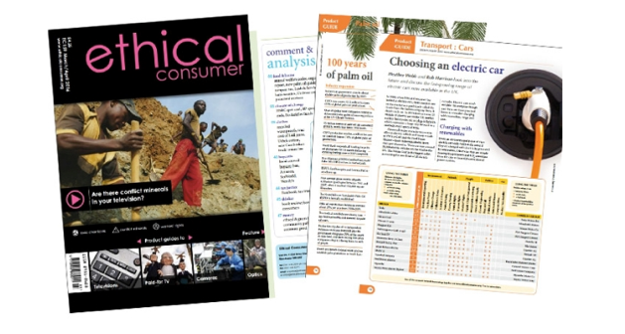

In support of Buddhist Action Month 2018, Ethical Consumer Magazine is offering a free copy of the magazine, as well as a special discounted subscription of 14 months for the price of 12. On top of that, BAM participants are welcome to share our subscription with our spiritual communities, meaning not only the magazine but also the website. In that case, choose a Username and Password that are straightforward, and make sure that nobody changes those details. For more information about this offer, visit http://www.ethicalconsumer.org/buddhistactionmonth.aspx.

Ethical Consumer has developed an easy-to-use ethical rating system based on detailed research of over 40,000 companies, brands and products. The ratings are updated daily and in real time from a Corporate Critic database, which is a result of over 20 years of primary and secondary research and systematic organisation and ratings. Some of this information is free to access, while the full set of tools is available for a small yearly subscription, which in turn helps fund the work.

Divest your money
Want to do something effective but don’t know where to start? One of the most tangible and straightforward things each of us can do is to financially withdraw our support from anti-social businesses. This is known as divestment. The historical precedent is the divestment campaign which helped end the apartheid system in South Africa. Currently, the two most successful global divestment campaigns are the Carbon Divestment Movement (“Go Fossil Free”), which is tackling climate change, and the Boycott, Divestment and Sanctions Movement, which focuses on the human rights issues in Palestine/ Israel.

Divesting is a perfect BAM precept. Changing one’s bank or funds may be annoying, but it’s not impossible. In addition to your personal accounts, why not tell others what you are doing and encourage them to do the same. Become a divestment champion for the month of June!

Divesting involves changing banks, pension funds or shares to those that do not engage in anti-social business. In the case of carbon divestment, this also means changing your electricity supplier to one that offers 100% green energy. By the end of 2016, more than $5 trillion worth of investment funds worldwide had divested from coal, oil and gas, and roughly half of that had occurred in 2016 alone. This implies a sea change that should fill us with optimism!

Carbon divestment is effective in three ways. The text that follows has been adapted from Go Fossil Free (https://gofossilfree.org/not-a-penny-more).

- Divest from fossil fuel companies.
Divestment holds the fossil fuel industry responsible for its culpability in the climate crisis. By shifting public support and our money away from the fossil fuel industry, we can break the hold that they have on our economy and our governments, while making way for a just transition to renewable energy.

- Defund new fossil fuel projects.
Financing any new fossil fuel project, anywhere, is unacceptable due to the dangers fossil fuels pose to society, ecosystems, and the planet. Local campaigns are pushing their cities and towns to stop using the banks backing fossil fuel development. It’s time for banks to stop the lines of credit and project-level loans to fossil fuel infrastructure like new pipelines or fracking drill rigs.

- Desponsor museums and cultural organisations.
We can shift public support away from the fossil fuel industry by pressuring our public institutions to break the sponsorship ties they have with many fossil fuel companies.

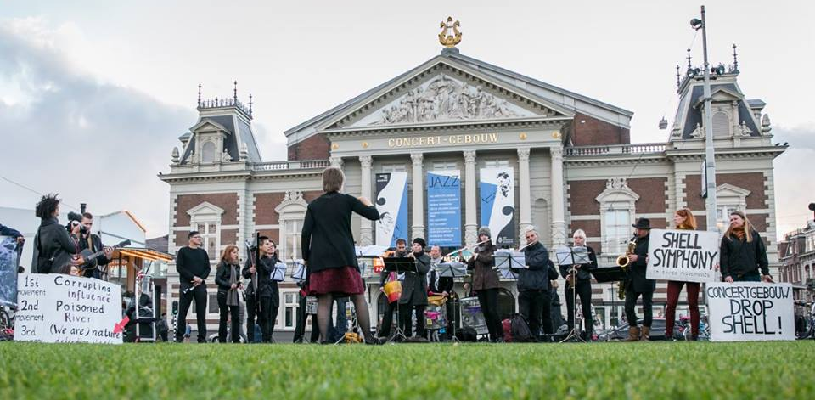
Music action to Drop Shell sponsorship at The Royal Concertgebouw in Amsterdam (Oct 5th, 2017). Image courtesy Kate Honey and Kate Ponchel.

Group BAM activities: organising for your spiritual community

Following are some tips and suggestions for organising on behalf of, or for, your spiritual community.
“Grace happens when we act with others on behalf of our world.”
~ Joanna Macy

Organising for your sangha
Working with others on a BAM event or action is a great opportunity to make friends, build sangha, and do something meaningful. Depending on your outlook, it can also be a tangible way of working towards your personal Pureland, developing your role towards the Bodhisattva Ideal, or other.

The best approach for organising and running a BAM event for your community or sangha is to do something you are personally interested in, and to establish a small group of people who are also interested and committed. That means you and your team will have a meaningful day, whether anyone else comes along or not.

Timing and logistics
Since June is a busy time of the year, the sooner your event is advertised, the better. If you belong to a Buddhist Centre that produces brochures to publicise its program, make sure you are in touch with the Centre team about your ideas for Buddhist Action Month well in advance. Time-wise, ideally we’d start in January to brainstorm what we wish to do, who will do what, and what dates work. Then start coordinating dates with the Centre by February, or March at the latest. Below is a rough chronology based on my own experience organising BAM events at Sheffield Buddhist Centre, which is a big centre with a busy calendar.

Within your spiritual community: |  | Timing
 | Brainstorming ideas, dates, etc. | January
 | Contact Centre team about ideas, dates, etc. | February
 | Provide Centre with blurb for web calendar and brochure | March- April
 | Create a poster for notice board
 | Post event on social media | mid-April
 | Mount poster/ notice board | May, June
 | Announce upcoming events at group gatherings | May, June
Tell the BAM community about it |  | Timing
 | BAM Facebook group | May, June
 | Twitter: #BuddhistActionMonth | June

Promoting your BAM action or event
Word-of-mouth is the finest form of promotion, so make this a number one priority in the time leading up to your event. Announcements at gatherings are invaluable, as questions can be answered on the spot. If you can’t make them yourself, ask others to help you with announcements, and with spreading the word in general. Posters are also an important form of promotion. Be sure to use the BAM logo (on the BAM Resources page of the NBO website), and to include all the vital information: date, time, place, what to expect, what to wear, what to bring, etc. If your event is open to participants from outside your spiritual community, make this clear and hang the poster in cafés or locations where it will be seen.

Social media is an excellent tool for connecting with others, particularly on projects in which participants are scattered around the world. Let’s use it for what it is worth, while infusing it with Dharma and positivity! Social media can bring people together, for real, while also building the sense of being part of a supportive network, one that is bigger than “me” or even “us”.

The BAM Facebook page (BAM! Buddhist Action Month 2018) is a central hub hosted by the NBO. Use it to showcase your event (possibly attracting participants from your area), and for sharing your BAM precepts and your experiences.

Twitter is really effective for compiling similar events and projects according to the hashtag with which they are ascribed. So, if we all use the hashtag #BuddhistActionMonth for our events, impressions, experiences and anything else associated with BAM, Twitter this will automatically collate these together. As suggested in the Introduction to the theme for BAM 2018, let’s use #myBAMdream2018 to share any real-world examples we that exemplify aspects of the kind of world we want the future to be like.

If you’re uncertain about using social media but want to give it a try, try following the steps outlined in the cartoon below. Otherwise, consider asking a friend to help get you started or to post on your behalf.

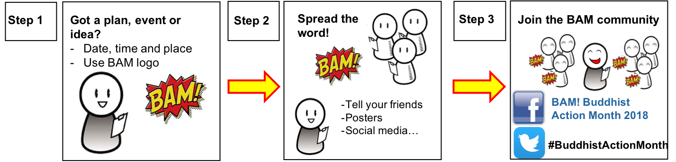

UN Sustainable Development Goals

On 1 January 2016, the world officially began implementing the 2030 Agenda for Sustainable Development, a transformative plan of action that is defined by 17 Sustainable Development Goals. The agenda is a road map for people and the planet to ensure sustainable social and economic progress world-wide. It seeks not only to eradicate extreme poverty, but also to integrate and balance the three dimensions of sustainable development - economic, social and environmental - in a comprehensive global vision.

As individuals and in groups, we can get involved in this great UN project. In the spirit of Buddhist Action Month, consider taking a single or some points that are relevant and bring this global project to life. Check out the Lazy Person’s Guide to Saving the World: https://www.un.org/sustainabledevelopment/takeaction

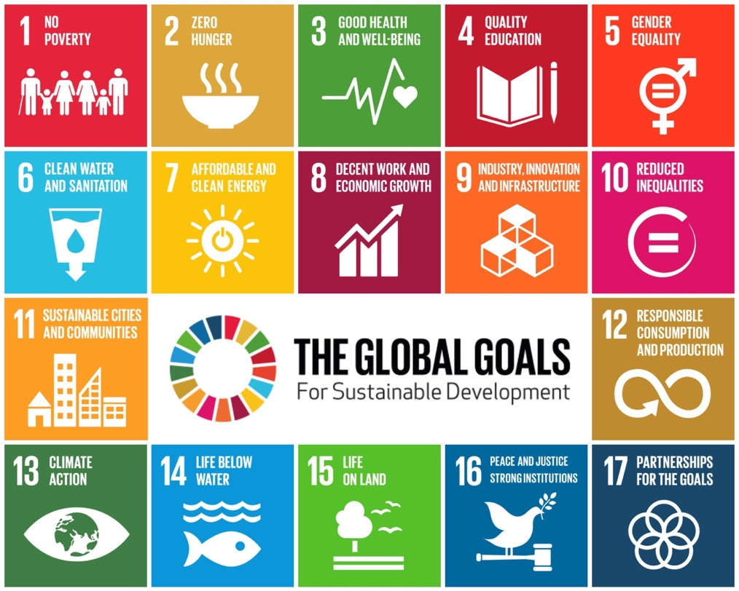

We can refer to the SDGs when we do something, embody a BAM precept, that aligns with any of the SDG goals. This can be illustrated using Twitter: if I were to switch my energy provider, I might Tweet something like this

#BuddhistActionMonth I’ve switched to @ecotricity and am helping to increase the share of renewable energy in the global energy mix @GlobalGoalsUN

Resources for our times

Good reads

Raworth, K. 2018. ‘Doughnut Economics: Seven Ways to Think Like a 21st Century Economist’. Cornerstone.

Monbiot, G. 2017. ‘Out of the Wreckage: a new politics for an age of crisis’. Verso.

Evans, A. 2016. ‘Eden 2.0: Climate Change and the Search for a 21st Century Myth’ Cameron.

Vaddhaka. 2015. ‘The Buddha on Wall Street’. Windhorse publications.

Marshall, G. 2014. ‘Don’t even think about it: why our brains are wired to ignore climate change’. Bloomsbury.

Graeber, D. 2013. ‘The Democracy Project: A History, a Crisis, a Movement’. Spiegel & Grau.
Rust, MJ & Totton, N. (eds) 2012 'Vital Signs' Karnac Books
Macy, J. & Johnstone, C. 2012. ‘Active hope’ New World Library

Singer, P. 2010. ‘The Life you can save: how to play your part in ending world poverty’. Picador.

Macy, J. 2010. ‘Pass It on: Five Stories That Can Change the World’. Parallax Press.

Jackson, T. 2009. ‘Prosperity Without Growth: Economics for a finite Planet’ Routledge.

Kessel, B. 2009. ‘It’s not about the money’. HarperCollins publishers.

Loy, D. 2008. ‘Money, sex, war, karma: Notes for a Buddhist revolution’. Wisdom publications.
Kaza, S. 2008. 'Mindfully Green' Shambhala.
Macy, J. 2007. ‘The Work that Reconnects’
Plotkin, B. 2007. ‘Nature and the Human Soul: Cultivating Wholeness and Community in a Fragmented World’. New World Library.
Klein, N. 2006. ‘The Shock Doctrine: The Rise of Disaster Capitalism’. Metropolitan Books.
Eisenberg, E. 2000 'Ecology of Eden' Picador.
Abram, D. 1997. 'The Spell of the Sensuous' Vintage.
Schumacher, EF. 1993. ‘Small is Beautiful’. Vintage publishing.

Macy, J. 1991. ‘World as Lover, World as Self’. Parallax Press.

Macy, J. 1991. ‘Mutual Causality in Buddhism and General Systems Theory: The Dharma of Natural Systems’. State University of New York Press.
Hunt Badiner, A. (ed)1990 'Dharma Gaia' Parallax Press.

Fims and documentaries

‘The Story of Stuff’ (series of films starting in 2007 to present)
‘Before the Flood’(2017)
‘Chasing Coral’ (2017)
‘Awake, a dream from Standing Rock’ (2017)
‘A Plastic Ocean’ (2016)
‘Minimalism: A Documentary About the Important Things’ (2016)
‘How to Let Go of the World and Love All the Things Climate Can't Change’ (2016)
‘The Bentley Effect’ (2016)
‘HyperNormalisation’ (2016)
‘WeTheUncivilised’ (2016)
'The Age of Stupid’ (2015)
'This Changes Everything' (2015)
‘Demain (Tomorrow)’ (2015)
‘Planetary’ (2015)
'Merchants of Doubt' (2014)
‘Joanna Macy and the Great Turning’ (2014)
'Cowspiracy' (2014)
'Do the math' (2013)
‘Bidder 70’ (2013)
‘Blackfish’ (2013)
‘Speed - In search of lost time’ (2012)
'Chasing Ice' (2012)
'Samsara' (2012)
'Gasland’ (2011)
'An Ecology of Mind' (2010)
'Animate Earth' (2009)
‘The Age of Stupid’ (2009)
‘The End of the Line’ (2009)
‘The Messenger’ (2009)
‘No Impact Man’ (2009)
‘Home’ (2009)
'Avatar' (2009)
'Who killed the electric car' (2006)
‘An Inconvenient Truth’ (2006)
‘Sharkwater’ (2006)
‘Power Trip’ (2003)
‘Winged Migration’ (2001)
‘Anima mundi’ (1992)
‘Koyaanisqatsi’ (1982)

Talks

Vaddhaka on ‘Going Beyond Capitalism (2014) (http://vimeo.com/96757414)

Joanna Macy on ‘Befriending our despair’ (2006) (https://vimeo.com/74502395)

Sangharakshita on Buddhism, Peace and Nuclear War (1984)
(https://www.freebuddhistaudio.com/audio/details?num=162)

Suggestions for BAM Activities
Personal BAM precepts, At Home
Create more space to 'just sit' in nature, to meditation, prayer, mantra, chanting, ritual or puja
Adjust the settings of your phone, or how you use your screens, to allow more space into your daily life
Use a garden composter or a vermicomposter to divert organic waste from landfill
If you have a garden, grow some food, learn about permaculture, create habitat for pollinators, birds, hedgehogs, etc.
Seek opportunities to be generous, to others, to yourself, to future generations
Mindful water consumption: initiate a method to avoid over-filling the kettle; avoid using hot water if you don't need it; reduce shower to two songs; Install gizmos/ flush limiters/ flow restrictors; Check for leaks/ check meter
Take time out to reflect on the world you wish to inhabit, and the world you wish to leave as a legacy
Travel with lower impact: use the car less and make sure the tyres are properly inflated; cycle or walk more; use public transport; consider car sharing
Adjust your diet: try veganism (at least 1 day/ week) , reduce plastic consumption by re-using bags, making your own toothpaste and deoderant.
Connect with the BAM community in person and on social media
Measure your carbon footprint and implement methods for reducing it
Install energy efficient lighting; Adjust hot water temperature; Heed appliance best practices; Block air draughts; Insulate around plumbing pipes, electrical cables, or any other holes or leaks using caulk or spray foam;
Adjust drapes and shades: install thermally lined curtains or roman blinds OR install pelmets OR create a good seal with curtains (length, distance from frame)
Use a clothesline instead of a dryer
Improve your recycling system (even if it means taking items to a recycling point, which your Council does not collect)
Switch your energy supply to a 100% renewable energy provider like Good Energy
Divest your money and savings and pension fund (https://gofossilfree.org)
Learn a verse by heart, recite it to birds and trees
Go on a ‘plastic diet’
For your local community, in your local community
Organise a litter-pick (with spiritual friends, neighbours, other faith groups, local community centre)
Run a cooking demonstration (e.g., healthy vegan, foraging, or using local produce or leftovers)
Run a planting day in your area: native, seasonal, pollinator-friendly plants
Guerilla gardening to make your area friendlier, tastier, and more beautiful: edible hedges, herbs, wildflower meadows
Promote the reduction of food waste, of buying local produce, of shopping organically
Organise a canal or beach clean-up with your local agencies
Join in/ plan a local "Great Get Together" (June 22-24, 2018), as part of the More in Common movement (http://www.greatgettogether.org/partners/faith-groups/)
Join your local Transition Town movement, maybe with some spiritual friends (https://transitionnetwork.org)
Get informed about fracking, consider lending your voice to the resistance in your community
Get more involved with a local co-operative
Subscribe to Ethical Consumer Magazine or The Positive News
At your Buddhist centre (if relevant)
Follow the Quakers’ lead: commit to becoming a ‘low–carbon sustainable centre’
Form an ‘eco-dharma team’ to make your Centre into a Sustainable Buddhist Centre
Switch your energy supply to a 100% renewable energy provider (e.g., Ecotricity, Good Energy)
Get your Centre to ‘go vegan’ for the month of June
Help your Centre to become a Fair Trade temple
Measure the carbon footprint of your Buddhist Centre (as a starting point to reducing it)
Produce a Centre newsletter devoted to issues around climate change / peak oil and how to engage with this.
Organise documentary film nights at your Centre and engage debate afterwards
Organise an Earth Hour: for an hour on a particular day, get together with others and be together without using any energy, either at your Buddhist Centre or at sangha homes
Research and host exercises from Joanna Macy’s ‘Work that Reconnects’
Promote cycling/ public transport/car sharing to the centre
Set up a food bank and donate food to a local charity that works with the homeless
Set up a Carbon Pledge Scheme, so people pledge x amount of ways they will reduce their energy usage
Resources for Guidance and Inspiration
Community action can received funding from the Big Lottery (grants up to £10k) (www.biglotteryfund.org.uk)
Carbon Calculator (http://www.carbon-calculator.org.uk)
Carbon Trust tools and resources (https://www.carbontrust.com/resources/tools/)
Sustainable Buddhist Centre certificate (https://thebuddhistcentre.com/system/files/groups/files/sustainable_buddhist_centre_guide_1.pdf)
Ethical consumer magazine and website (www.ethicalconsumer.org)
Freecycle (www.freecycle.org)
Friends of the Earth (www.foe.co.uk)
Groundwork (try your local branch) (www.groundwork.org.uk )
Housing Associations or Registered Social Landlords
Incredible Edible (https://www.incredible-edible-todmorden.co.uk)
Love food hate waste (https://www.lovefoodhatewaste.com)
New Economics Foundation (http://www.neweconomics.org )
The Quakers in Britain (http://www.quaker.org.uk/our-work/sustainability)
Third Sector Organisations, like local charities and voluntary groups (web search ‘environment’ or ‘ litter picking’ and your town/ city)
Woodland conservation (some funding available) (www.woodlandtrust.org.uk)
Go Fossil Free (https://gofossilfree.org)
Guerilla Gardening (http://guerrillagardening.org)
UN SDGs Lazy Person’s Guide to Saving the World (https://www.un.org/sustainabledevelopment/takeaction/)

Verses for inspiration

The Karaniya Mettā sutta

Mettā (maitri: Sanskrit) means loving-kindness or friendliness, and Karaṇīyam means "(This is what) should be done". The sutta describes a complete path that begins with Right Vision, progresses through ethics and, with the cultivation of metta, arrives at Insight.

This discourse, or sutta in Pali (sutra: Sanskrit) summarises the Buddha’s instructions on the cultivation of universal loving-kindness. It is said to have been taught by the Buddha to a group of monks troubled by the animosity of tree-devas, spirits who dwelled in the trees of the grove they had chosen for their retreat. Through recitation and meditation, and perhaps supported by the befriended devas, the monks eventually gained Enlightenment.

The Buddha’s words on loving-kindness

This is to be done by one skilled in aims
who wants to break through to the state of peace:
Be capable, upright, & straightforward,
easy to instruct, gentle, & not conceited,
content & easy to support,
with few duties, living lightly,
with peaceful faculties, masterful,
modest, & no greed for supporters.

Do not do the slightest thing that the wise would later censure.

Think: Happy, at rest,
may all beings be happy at heart.
Whatever beings there may be, without exception:
weak or strong,
long, large,
middling, short,
subtle, blatant,
seen & unseen,
near & far,
born & seeking birth:
May all beings be happy at heart.

Let no one deceive another
or despise anyone anywhere,
or through anger or irritation
wish for another to suffer.

As a mother would risk her life
to protect her child, her only child,
even so should one cultivate a limitless heart
with regard to all beings.
With good will for the entire cosmos,
cultivate a limitless heart:
Above, below, & all around,
unobstructed, without enmity or hate.

Whether standing, walking,
sitting, or lying down,
as long as one is alert,
one should be resolved on this mindfulness.
This is called a sublime abiding
here & now.

Not taken with views,
but virtuous & consummate in vision,
having subdued desire for sensual pleasures,
one never again
will lie in the womb.

"Karaniya Metta Sutta: Good Will" (Sn 1.8), translated from the Pali by Thanissaro Bhikkhu. Access to Insight (BCBS Edition), 30 November 2013, http://www.accesstoinsight.org/tipitaka/kn/snp/snp.1.08.than.html

“Active Hope”, by Joanna Macy

Active Hope is not wishful thinking.
Active Hope is not waiting to be rescued . . . . by some saviour.
Active Hope is waking up to the beauty of life on whose behalf we can act.
We belong to this world.
The web of life is calling us forth at this time.
We’ve come a long way and are here to play our part.
With Active Hope we realize that there are adventures in store,
strengths to discover, and comrades to link arms with.
Active Hope is a readiness to discover the strengths
in ourselves and in others;
a readiness to discover the reasons for hope
and the occasions for love.
A readiness to discover the size and strength of our hearts,
our quickness of mind, our steadiness of purpose,
our own authority, our love for life,
the liveliness of our curiosity,
the unsuspected deep well of patience and diligence,
the keenness of our senses, and our capacity to lead.
None of these can be discovered in an armchair or without risk.”

“This is Your Age”, a Poem for Generation Hope
On March 17th 2018, Soka Gakkai International (SGI) hosted a meeting across three venues in the UK to unite 6000 young people in a shared commitment for peace. SGI is a socially engaged movement based on Nichiren, in which Soka means the 'creation of value' and Gakkai means 'society'. SGI teacher, Daisaku Ikeda prepared a poem for that meeting.

This is Your Age
This is your age
The future rests in your hands
I hope you will make the twenty-first century truly wonderful
Please make it a century in which the life of each individual is cherished and respected to the utmost.
A century without discrimination, without bullying, war or murder.
A century in which no child cries with hunger, in which no mothers or children take their own lives in despair.
A century without environmental destruction.
A century free from academic elitism, greed and materialism.
A century in which human rights are upheld as the most precious treasure.
A century of true democracy, in which the people hold corrupt political leaders to account. A century in which the people exercise sound judgement and pay no heed to the lies of the mass media.
I hope you will make it a century in which each of your precious dreams come true and your unique individuality blossoms to the fullest.
To realise these goals, it is vital that you achieve victory, that each of you grow into people of philosophy and compassion, into people who possess both real ability and the sincerity to understand the hearts of others.
Your victory will be the victory of the twenty-first century.
You are our only hope.

© Daisaku Ikeda

Letter of encouragement from Nichiren

Live so that all the people of Kamakura will say in your praise that Nakatsukasa Saburō Saemon-no-jō is diligent in the service of his lord, in the service of Buddhism, and in his concern for other people. More valuable than treasures in a storehouse are the treasures of the body, and the treasures of the heart are the most valuable of all. From the time you read this letter on, strive to accumulate the treasures of the heart! (13th century Japan)

“Service to humanity is another name for Zen training”

In his 2013 book, ‘Not Everything is Impermanent’ (Woodsmoke Press), the Head of Amida Shu, Dharmavidya David Brazier, wrote:

The spiritual apostle goes forth for the benefit of the many. This does not mean that such people are opposed to the practise of a mystical discipline. Nothing could be further from the truth. I was taught by my Zen Master that “Service to humanity is another name for Zen training”. For “Zen” one can read “mysticism”, the deeper experiences of the spirit that arise through the discipline of religious prayer, reflection and meditation.

A hallmark of spirituality, as I understand it, is the bringing together of two dimensions of religious life: the socially engaged and the direct seeing into the heart of reality. Tearing these two apart does profound damage to the human spirit. Nonetheless it is common and many people fail to see how the two come together as one. (p. 193)

A Verse from the Buddha’s Udana (not decided yet)

Description of the Bodhisattva Ideal (e.g., Mahagovinda sutta; Buddhavamsa of the Khuddaka-Nikaya) (not decided yet/ found yet)

Verse from Dhammapada in Joy chapter (not found yet)

Visuddhimagga sutta: Path of Purity (not found yet)

Recycling sutta

